Firm Real-Time System

Definition
# Source: AI Source: Provided by: [Data Path: Persons Table -> ID Column: 1, Name_En Column: Motasem Essam] -> From: [ChatGPT] on [1/21/2026]
A Firm Real-Time System is a type of real-time system that lies between hard and soft real-time systems. In this system, meeting deadlines is important, but unlike hard real-time systems, missing an occasional deadline is tolerable—though the results of that task are discarded.

Key Characteristics
# Source: AI Source: Provided by: [Data Path: Persons Table -> ID Column: 1, Name_En Column: Motasem Essam] -> From: [ChatGPT] on [1/21/2026]
- Important Deadlines – Tasks must ideally finish on time; late results are useless.
- No Catastrophe for Missed Deadlines – Missing a deadline does not crash the system, but the output is ignored.
- Periodic Tasks – Often used in systems with recurring tasks where outdated results have no value.
- Graceful Handling of Missed Deadlines – The system continues with subsequent tasks.

Examples
# Source: AI Source: Provided by: [Data Path: Persons Table -> ID Column: 1, Name_En Column: Motasem Essam] -> From: [ChatGPT] on [1/21/2026]
- Stock market trading systems – Late price updates are ignored.
- Reservation systems – Outdated booking information is discarded.
- Some industrial automation processes – If a periodic sensor reading is late, it is skipped and the next reading is processed.

Comparison with Hard and Soft Real-Time Systems
# Source: AI Source: Provided by: [Data Path: Persons Table -> ID Column: 1, Name_En Column: Motasem Essam] -> From: [ChatGPT] on [1/21/2026]
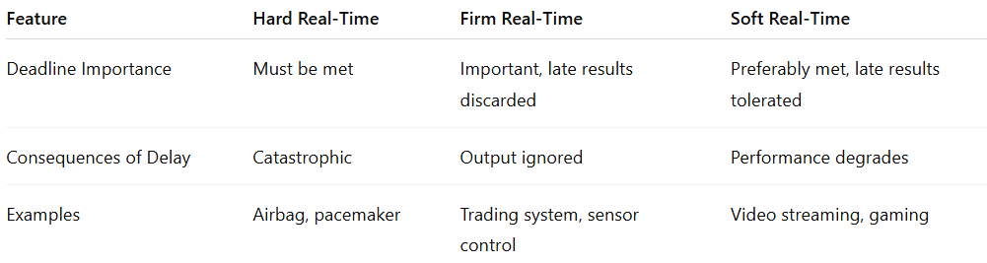
Feature | Hard Real-Time | Firm Real-Time | Soft Real-Time
Deadline Importance | Must be met | Important, late results discarded | Preferably met, late results tolerated
Consequences of Delay | Catastrophic | Output ignored | Performance degrades
Examples | Airbag, pacemaker | Trading system, sensor control | Video streaming, gaming

In short, firm real-time systems treat deadlines seriously, but the system can safely ignore late outputs without total failure.

